LAB 4: ADOBE ILLUSTRATOR

# Introduction

Adobe Illustrator is a leading vector graphics editor developed by Adobe Inc., widely recognized for its versatility and precision in creating a broad spectrum of visual content. Whether designing logos, crafting intricate illustrations, or working on complex typography, Illustrator's

comprehensive suite of tools makes it indispensable for both professional designers and creative enthusiasts. This lab aims to introduce the fundamental functionalities of Adobe Illustrator,

providing a solid foundation for anyone looking to explore and master vector graphic design.

In this lab, you will embark on a hands-on journey through Adobe Illustrator's diverse capabilities. Beginning with an introduction to the workspace, you'll learn to navigate the

interface efficiently, understanding the significance of key elements like the artboard, panels, and toolbars. As you progress, the lab will delve into the creation and manipulation of basic shapes, which are essential building blocks for more complex designs.

A significant portion of the lab is dedicated to mastering the pen tool, a powerful feature that allows for the creation of custom designs with precision. You'll learn how to edit paths and

anchor points, enabling you to refine your vector graphics with accuracy. Additionally, the lab will cover the application and adjustment of fill and stroke colors, the use of gradients, and the importance of selecting appropriate color modes, which are crucial for achieving the desired

visual effects in your projects.

Beyond the basics, this lab will explore the integration of typography in design, teaching you how to add and format text while adhering to key typography principles. You'll also learn how to organize your work by managing layers, grouping objects, and applying effects. The use of

transparency and blending modes will be introduced, further enhancing your ability to create dynamic and visually appealing designs.

By the end of this lab, you will have gained a thorough understanding of Adobe Illustrator's core functions, equipping you with the confidence to tackle a wide range of graphic design projects.

This foundational knowledge will serve as a stepping stone to more advanced techniques and creative possibilities within the world of vector graphics.

# Objectives

The main objectives of this lab work are:

1. Brief Overview of Adobe Illustrator
2. Tools and Techniques
   * Basic Tools and Their Functions
   * Creating and Manipulating Basic Shapes
   * Using Pen Tools for Creating Custom Shapes
3. Color and Gradients
   * Applying and Editing Fill and Stroke Colors
   * Working with Gradients
   * Understanding Color Modes
4. Text and Typography
   * Adding and Formatting Text
5. Layers
   * Understanding and Organizing Layers
   * Grouping and Ungrouping Objects
6. Effects and Appearance
   * Applying and Customizing Effects
   * Working with Transparency and Blending Modes
   * Using Pathfinding Tool
7. Saving and Exporting Your Work

# Brief Overview of Adobe Illustrator

* + Installing Adobe Illustrator:
    - Visit the Adobe Creative Cloud website and download Adobe Illustrator.
    - Follow the installation instructions provided by Adobe.
    - Launch Illustrator once the installation is complete.

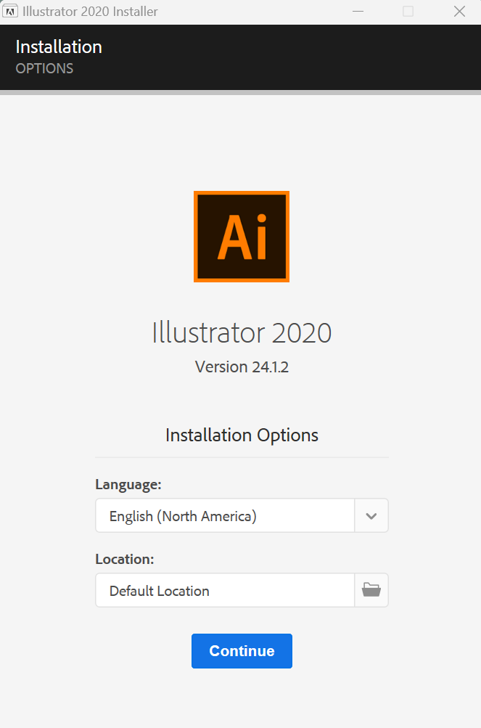

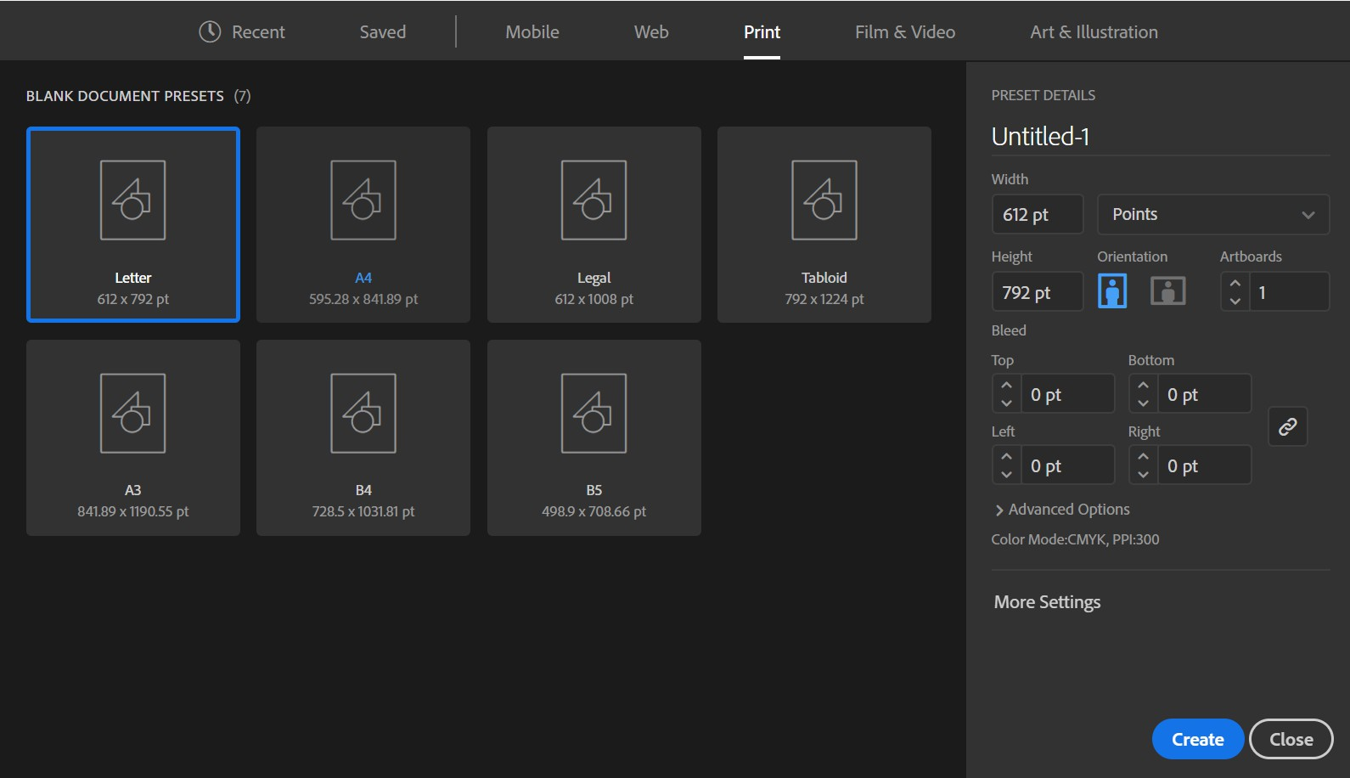

* + 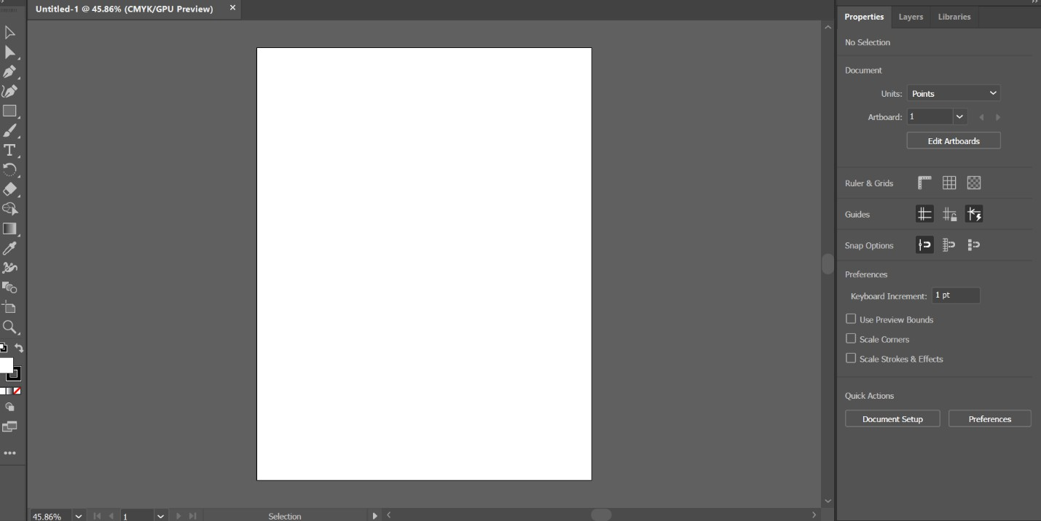Understanding the Workspace:
* Toolbar: Located on the left side of the screen, it contains tools for drawing, selecting, and editing.
* Properties Panel: On the right side, it shows options related to the selected tool or object.
* Stage: The central canvas area where you create your artwork.

# Tools and Techniques

## Basic tools and their functions

* + Selection Tool
    - Function: Selects entire objects for moving, resizing, or transforming.
    - How to Use: Click on an object to select it. You can then drag to move, or use the handles on the bounding box to resize or rotate the object.
  + Direct Selection Tool
    - Function: Selects and modifies individual anchor points and path segments within an object.
    - How to Use: Click on an anchor point or path segment to select it. Drag anchor points or path segments to adjust the shape of the object.
  + Pen Tool
    - Function: Creates custom shapes and paths by placing anchor points and creating curves.
    - How to Use: Click to place anchor points for straight segments. Click and drag to create curves. Close the path by connecting back to the starting point or double- clicking.
  + Curvature Tool
    - Function: Creates and edits smooth curves more intuitively than the Pen Tool.
    - How to Use: Click to place points and create curves. Adjust the shape of the curves by dragging the points to change the curve direction.
  + Rectangle Tool
    - Function: Draws rectangles and squares.
    - How to Use: Click and drag on the canvas to create a rectangle. Hold Shift while dragging to create a perfect square.
  + Paint Brush Tool
    - Function: Paints freeform strokes and textures with various brush styles.
    - How to Use: Select a brush from the Brush panel. Click and drag on the canvas to draw with the selected brush. Adjust brush size and style in the Brush panel.
  + Type Tool
    - Function: Adds text to your artwork.
    - How to Use: Click on the canvas to create a text box and start typing. Adjust font, size, and other text properties in the Character panel.
  + Rotate Tool
    - Function: Rotates objects around a fixed point.
    - How to Use: Select an object and click the Rotate Tool. Click and drag to rotate the object around its center or specified anchor point. Hold Shift to constrain rotation to 45-degree increments.
  + Eraser Tool
    - Function: Removes parts of objects or artwork.
    - How to Use: Click and drag over the area you want to erase. Adjust the size and shape of the eraser in the options bar.
  + Shape Builder Tool
    - Function: Combines, subtracts, and merges overlapping shapes.
    - How to Use: Select multiple overlapping shapes. Click and drag across areas you want to combine or subtract. Hold Alt (Option) while dragging to subtract from the selection.
  + Gradient Tool
    - Function: Applies and adjusts gradients on objects.
    - How to Use: Select an object and then click and drag with the Gradient Tool to apply a gradient. Adjust gradient stops and direction in the Gradient panel.
  + Eyedropper Tool
    - Function: Samples colors from objects and applies them to other objects.
    - How to Use: Click on a color in your artwork to sample it. The sampled color will become the current fill or stroke color.
  + Width Tool
    - Function: Adjusts the width of paths along their length.
    - How to Use: Click on a path to create width points. Drag these points to adjust the width of the path at different locations.
  + Blend Tool
    - Function: Creates smooth transitions between objects.
    - How to Use: Select two objects and use the Blend Tool to create a blend between them. Adjust the number of steps or the spacing in the Blend Options dialog.
  + Fill and Stroke
    - Function: Controls the color and appearance of the inside (fill) and the outline (stroke) of objects.
    - How to Use:
      * Fill: Click the Fill color box in the toolbar or Properties panel to choose a color or gradient for the interior of the object.
      * Stroke: Click the Stroke color box to choose a color for the outline. Adjust the stroke width and style in the Stroke panel.

## Creating and manipulating basic shapes

* + Draw Shapes:



* + - Select a shape tool from the toolbar.
    - Click and drag on the canvas to create the shape.
  + Transform Shapes:

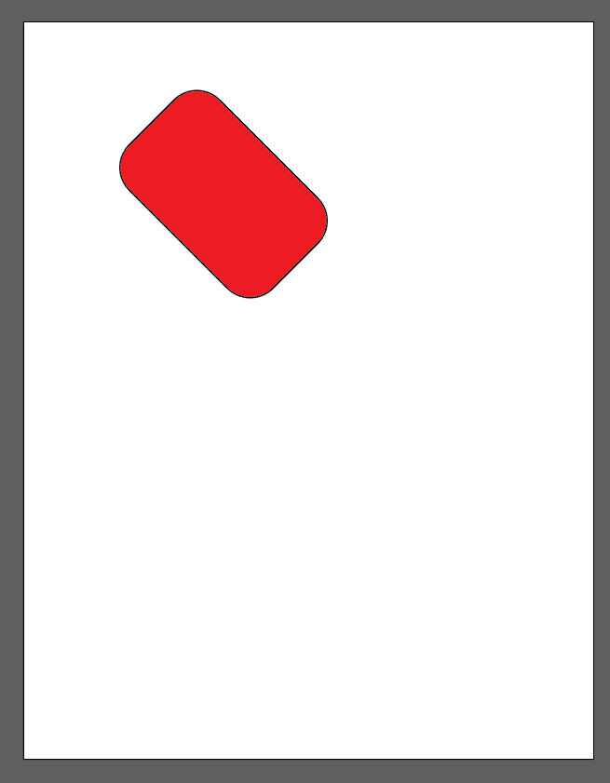

* + - Resize: Click and drag the corners of the bounding box around the shape.
    - Rotate: Hover near the corners of the bounding box until a rotate icon appears, then drag to rotate.
    - Skew: Hold Shift while dragging to skew the shape.

## Using pen tools for creating custom shapes

* + Draw with the Pen Tool:
    - Click to create straight segments. Click and drag to create curves.
    - To close a path, click on the initial anchor point.

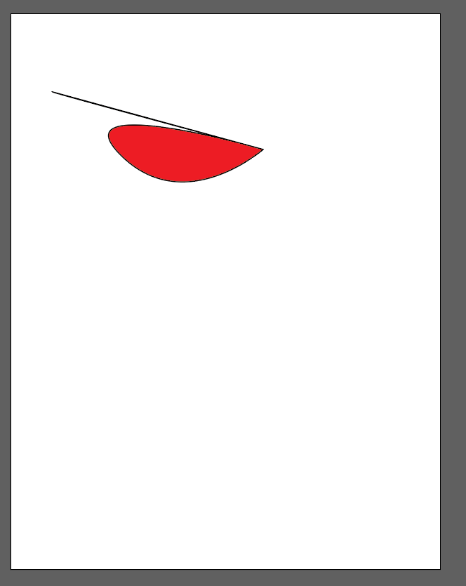

* + Modify Paths:

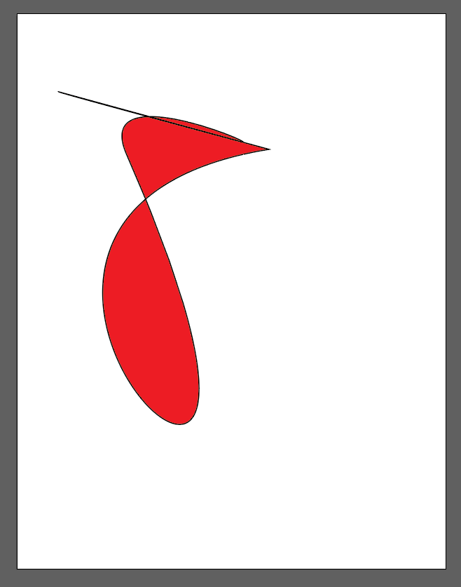

* Use the Direct Selection Tool to adjust individual anchor points and curve handles.

# Color and Gradients

## Applying and editing fill and stroke color

* + Fill Color:
    - Select the Fill color box in the toolbar or Properties Panel.
    - Choose a color from the Color Picker or Swatches panel.
  + Stroke Color:
    - Select the Stroke color box in the toolbar or Properties Panel.
    - Choose a color similarly to the Fill color.

## Working with gradient

* + Apply a Gradient:

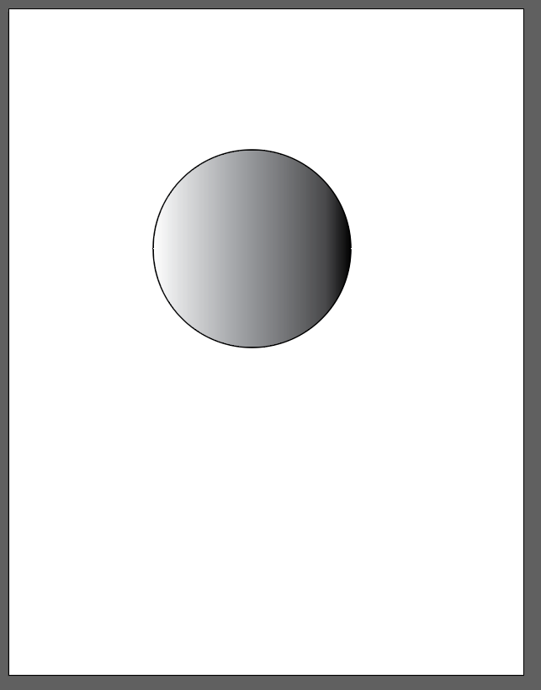

* Select an object.
* Choose the Gradient Tool (G) from the toolbar or use the Gradient panel to apply and adjust the gradient.
  + Edit Gradients:

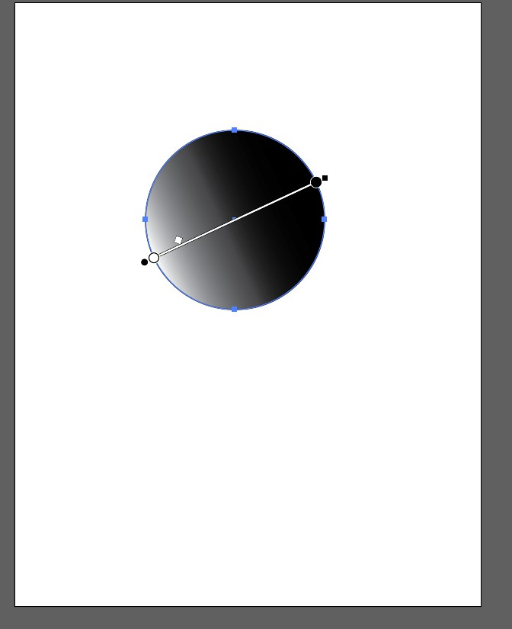

* Adjust gradient stops and colors in the Gradient panel.
* Change the gradient direction and type (linear or radial).

## Understanding color modes

* + RGB:
    - Used for digital screens. Colors are created by mixing Red, Green, and Blue.
  + CMYK:
    - Used for print. Colors are created by mixing Cyan, Magenta, Yellow, and Black.
  + Setting Color Mode:
    - Go to File > Document Color Mode and select either RGB or CMYK based on your project needs.

1. Text and Typography
   * Adding and formatting text
     + Add Text:

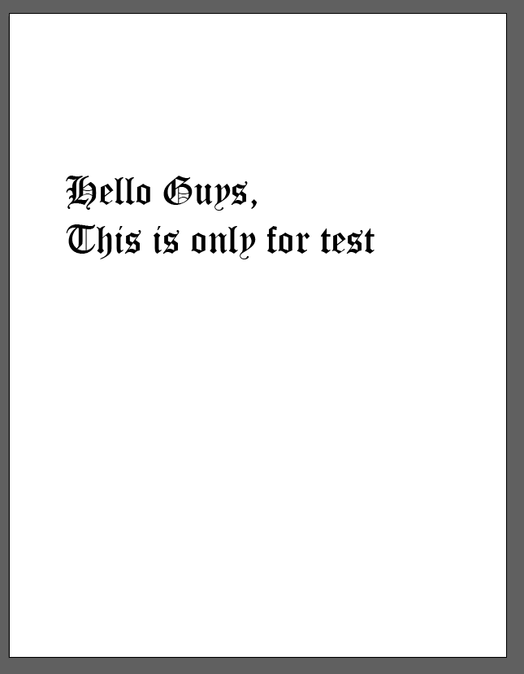

* + - * Select the Type Tool (T) and click on the canvas to create a text box.
      * Type your text.
  + Format Text:

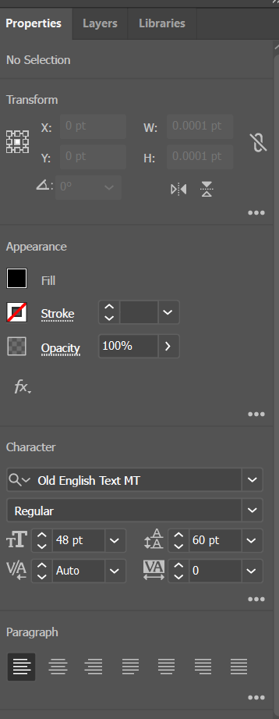

* + - Use the Properties panel to change font, size, color, and other typographic settings.

# Layers

## Understanding and Organizing Layers

* + Layers Panel:

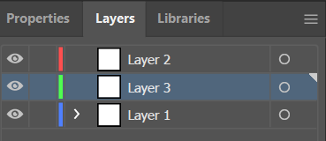

* + - Open the Layers panel to view and manage layers.
    - Use the panel to add, delete, or reorder layers.
  + Organize Layers:
    - Group related objects into layers for better management.
    - Lock or hide layers to work on specific parts of your artwork.

## Grouping and Ungrouping Objects

* + Group Objects:
    - Select multiple objects and press Ctrl + G (Cmd + G) to group them.
  + Ungroup Objects:
    - Select a grouped object and press Ctrl + Shift + G (Cmd + Shift +G) to ungroup.

1. ​Effects and Appearances

## Applying and customizing effects

* + Apply Effects:

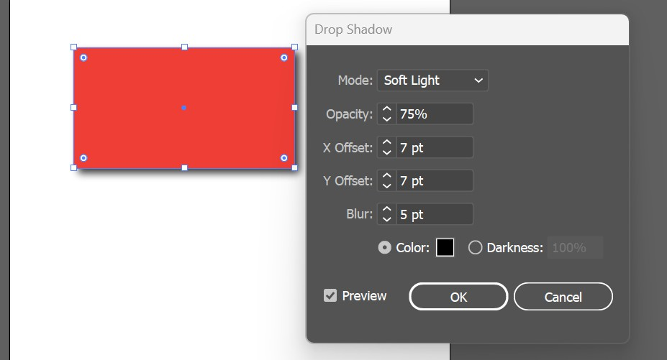

* + - Select an object and go to Effect in the menu to apply effects like Drop Shadow, Glow, etc.
  + Customize Effects:
    - Use the Appearance panel to adjust the settings of applied effects.

## Working with transparency and blending mode

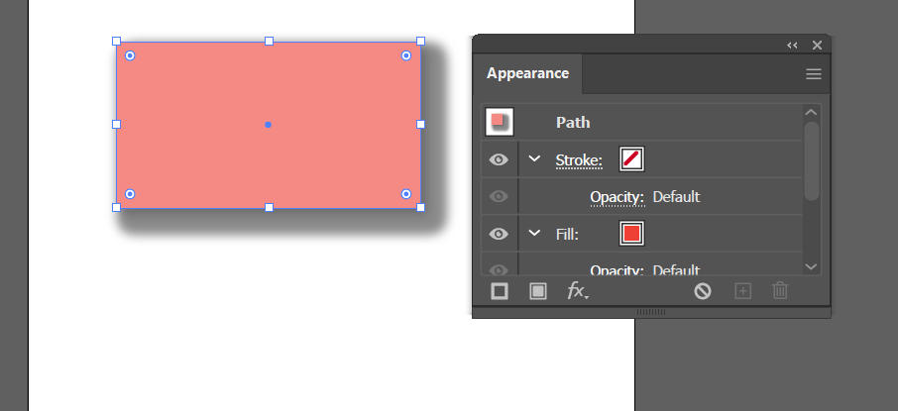

* + Transparency:
    - Select an object and adjust its opacity in the Transparency panel.
  + Blending Modes:
    - Experiment with different blending modes in the Transparency panel to see how colors blend with underlying layers.

## Using pathfinding tool

* + Pathfinder Panel:
* Open the Pathfinder panel to use options like Unite, Minus Front, Intersect, and Exclude to combine or modify shapes.

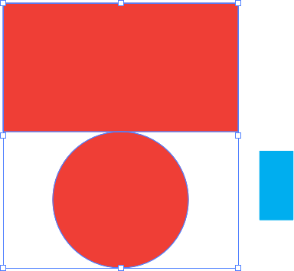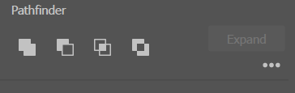

1. ​Saving and Exporting

## Save

* + Save the project in the .ai format to preserve all editing capabilities. Go to File Save As and choose Adobe Illustrator (AI) format.

## Export Options

* + To export the artwork for web or print, go to File &gt; Export and choose the format (e.g., PNG, JPEG, SVG, PDF).

## Export Settings

* + Configure export settings based on the needs (resolution, color profile, etc.) for optimal results.

Conclusion

This lab provided a comprehensive introduction to the core features of Adobe Illustrator, guiding me through the essential aspects of the software. From the initial setup to navigating the workspace, I gained a solid understanding of Illustrator’s interface and tools. I learned how to create and manipulate basic shapes, which are fundamental to vector design, and I became proficient with the Pen and Curvature tools, allowing for the creation of custom designs with precision.